**TASK REPORT**

**ALGORITHMS AND DATA STRUCTURE**

**WEEK 2**

**Created by:**

**Onic Agustino**

**L200234275**

**X**

**INFORMATICS ENGINEERING**

**FACULTY OF COMMUNICATION AND INFORMATICS**

**UNIVERSITAS MUHAMMADIYAH SURAKARTA**

**2024/2025**

**TASK**

1. **Rubic for Prime or No**

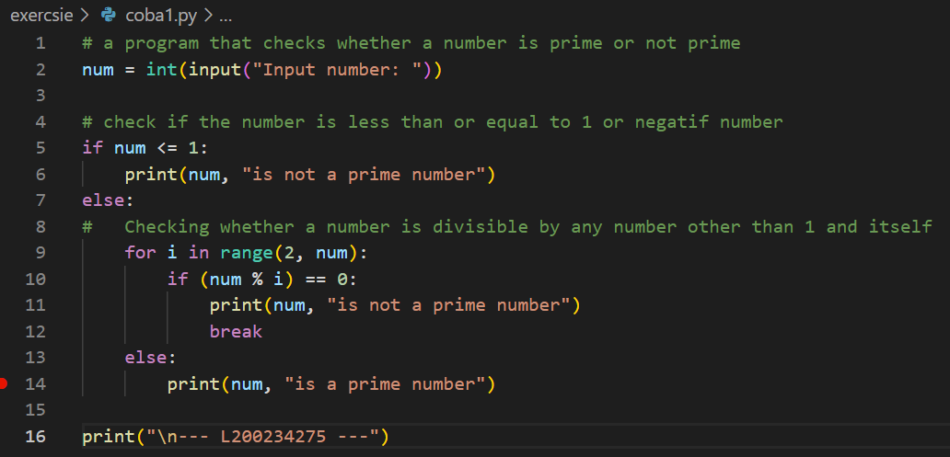

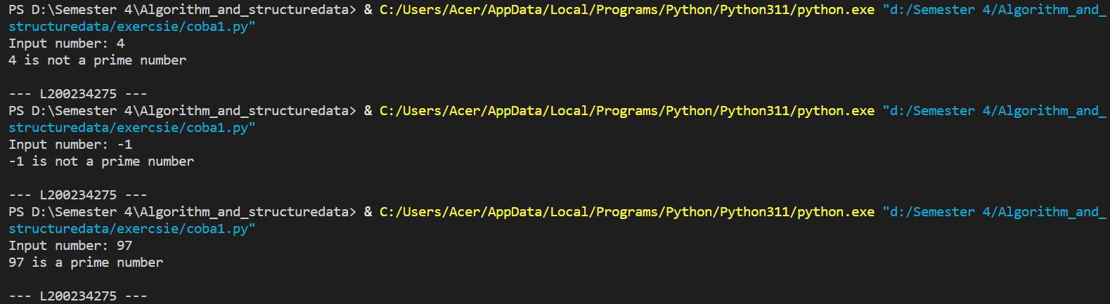

1. **Rubic for Remove Repetitive Items**

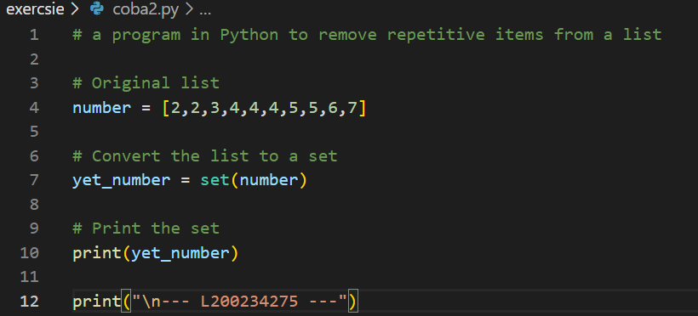



1. **Rubic for Sum All Number**

